

**VA Form 21P-527EZ**Pension Benefits Application

Version 1.0 (re-release)  
January 2024

Table of Contents

Overview

User Access

Navigation

How Do I Apply?

Pension Benefits Application  
Step 1: Applicant Information

Step 1: Applicant Information/Mailing Address

Step 1: Applicant Information/Email and Phone Number

Step 2: Military History

Step 3: Health and Employment Information/Age

Step 3: Health and Employment Information/Social Security Disability

Step 3: Health and Employment Information/Special Monthly Pension

Step 3: Health and Employment Information/Treatment From a VA Medical Center

Step 3: Health and Employment Information/Treatment From Federal Medical Facilities

Step 3: Health and Employment Information/Current Employment

Step 4: Household Information/Marital Status

Step 4: Household Information/If Married or Separated

Step 4: Household Information/Previous Marriage

Step 4: Household Information/Current Marriage

Step 4: Household Information/Current Marriage if They Do Not Live With Spouse

Step 4: Household Info/Married or Separated and Current Spouse Was Previously Married

Step 4: Household Information/Dependent Children

Step 5: Financial Information/Income and Assets

Step 5: Financial Information/Gross Monthly Income

Step 5: Financial Information/Care Expenses

Step 5: Financial Information/Medical Expenses

Step 6: Additional Information/Direct Deposit

Step 6: Additional Information/Supporting Documents

Step 6: Additional Information/Submit Your Supporting Documents

Step 6: Additional Information/Faster Claim Processing (Optional)

Step 7: Review Application

Overview

This product guide covers the online application for Veteran pension benefits (21P-527EZ).

U.S.er Access

Who can access this application?

Veterans do not need to sign in to complete this application. However, if they don’t sign in, the application prefills with their information and the Veteran cannot save their application in progress. You can reference the screenshot below for more details.  
  
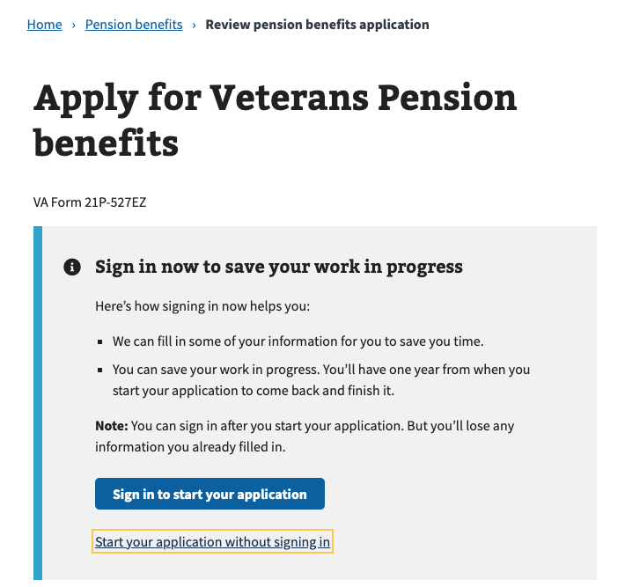

Navigation

Direct URL: https://www.va.gov/pension/application/527EZ/introduction

Or via the dropdown menu:

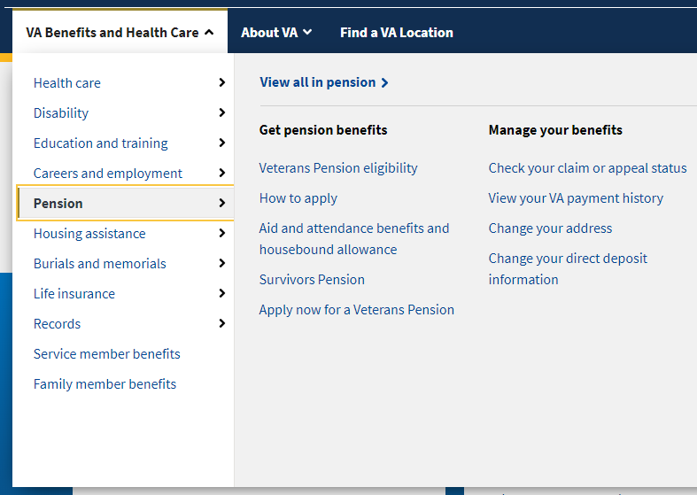

Or on the Pension Benefit Hub Page: https://www.va.gov/pension/

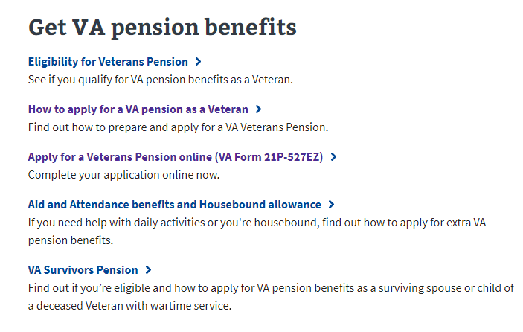

How Do I Apply?

https://www.va.gov/pension/how-to-apply/

This web page provides instructions on how to apply for Veterans pension benefits and what information is needed to complete the application. This page also directs the U.S.er to the application once they are ready to apply:

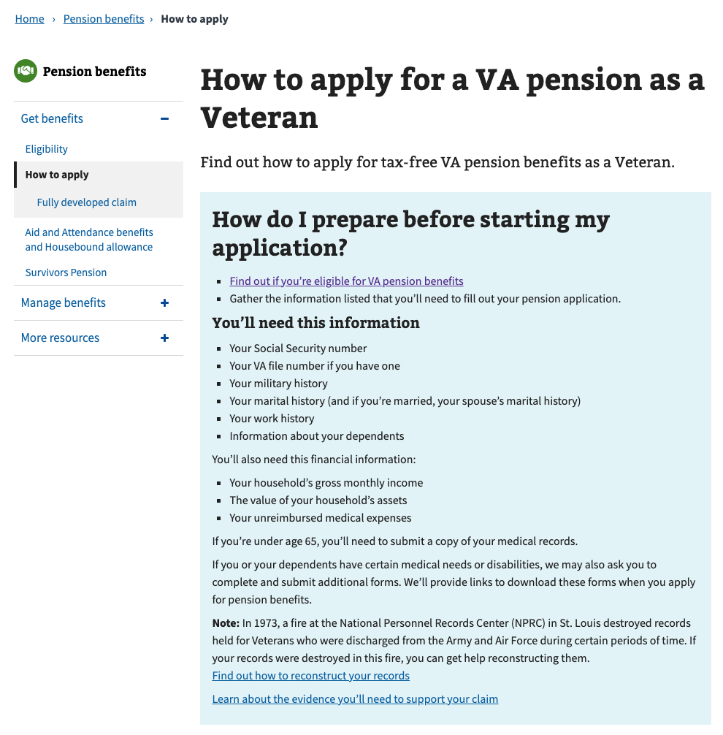

Pension Benefits Application

Step 1: Applicant Information

First, the U.S.er is asked to fill in general personal information. If they are signed in, the application is pre-filled, but the Veteran can change this information. If they are not signed in, they must add the information.

The application tells the Veteran what they must fill in. If they do not enter all the required information, they cannot move on to the next page.

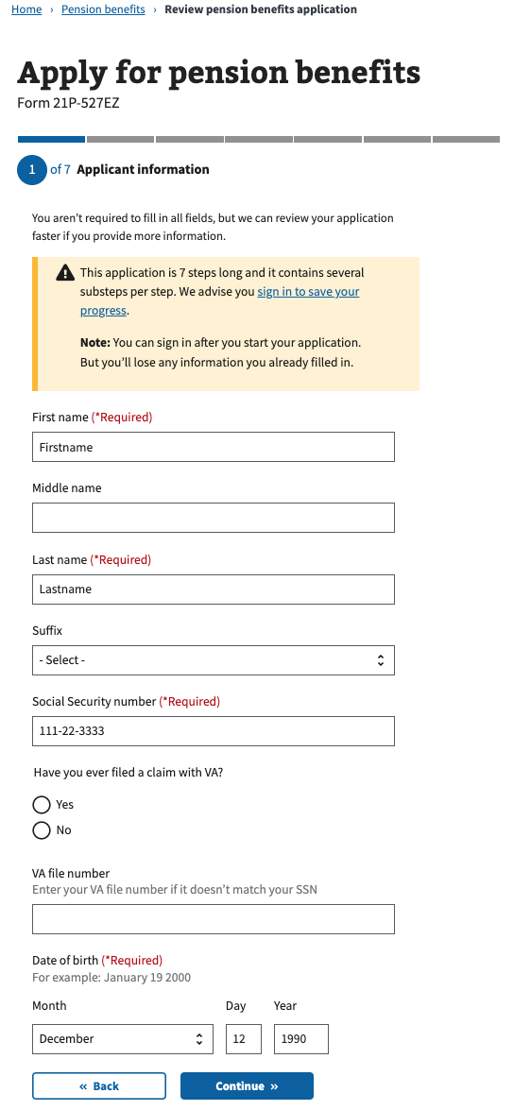

Step 1: Applicant Information/Mailing Address

Next, the Veteran is asked to enter their mailing address. If they check the box that they receive mail outside of the U.S. on a military base, the United States is automatically deselected.

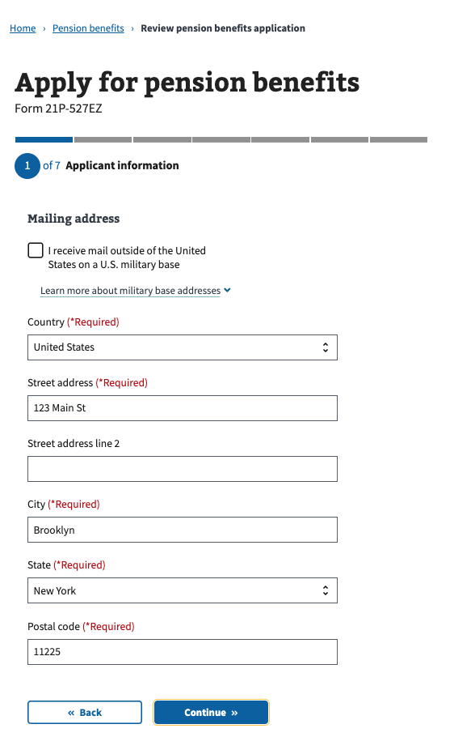

Step 1: Applicant Information/Email and Phone Number

Next, the Veteran is asked to enter their email address and phone number(s), including an international phone number if they have one.

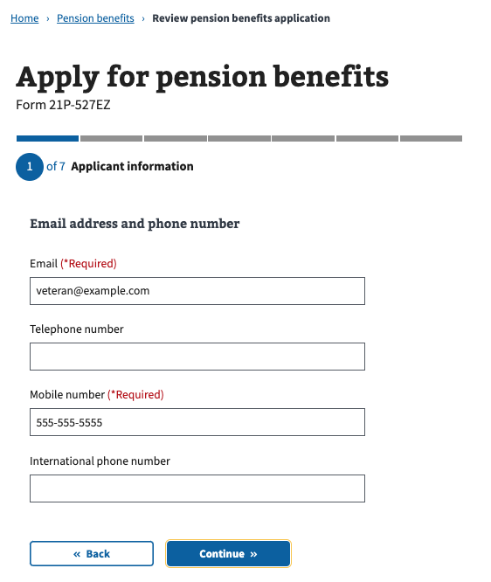

Step 2: Military History

Next, the Veteran is asked to enter their branch(es) of service, the dates they entered and ended their active duty, and a military service number if they have one:

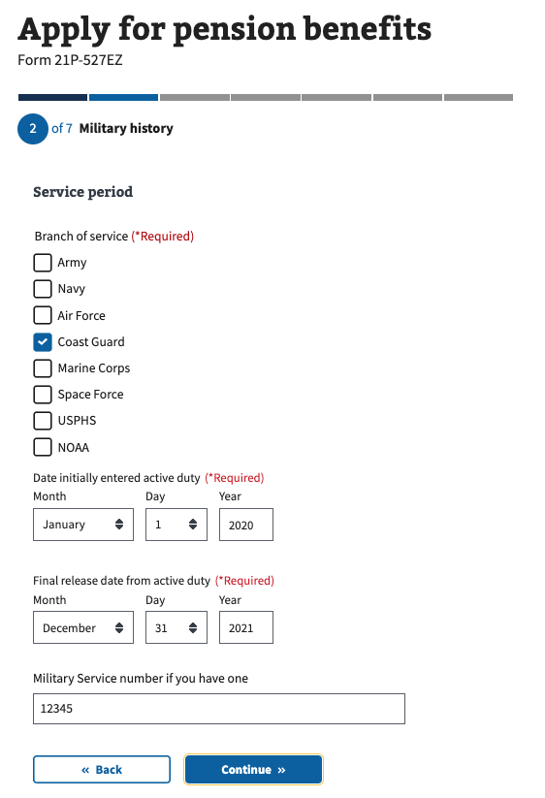  
  
The Veteran is also asked if they served under another name. If so, they must enter that name and their place of separation from service:

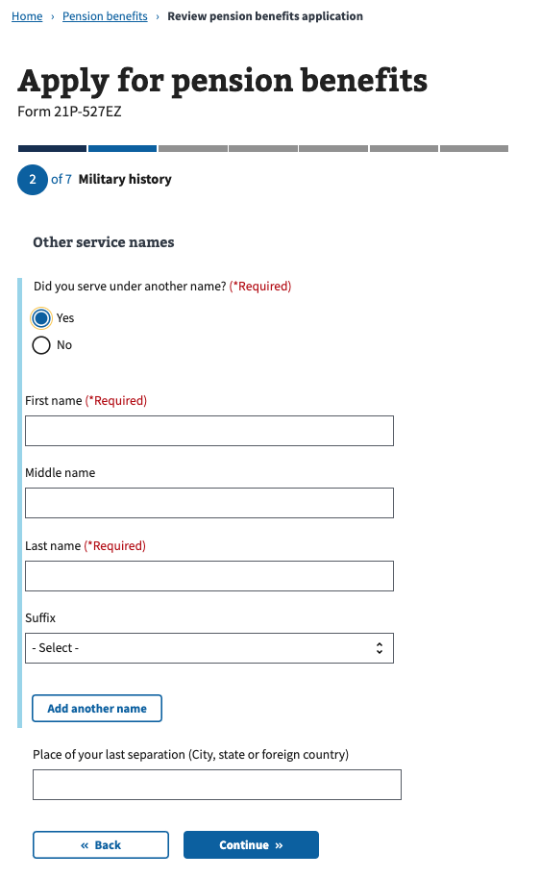

The Veteran is also asked if they have ever been a prisoner of war (POW). If so, they are asked to enter their confinement start and end dates:

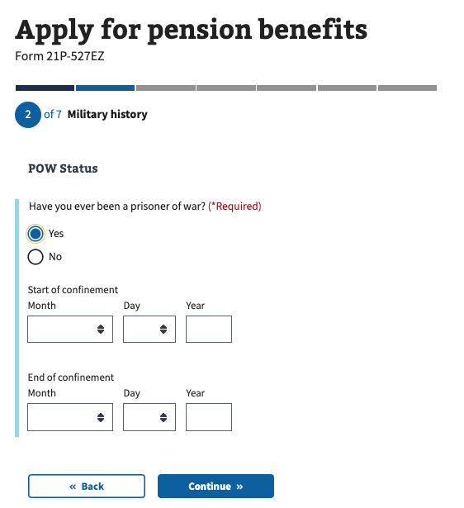  
  
Step 3: Health and Employment Information/Age

Next, the Veteran is asked whether they are 65 years or older:

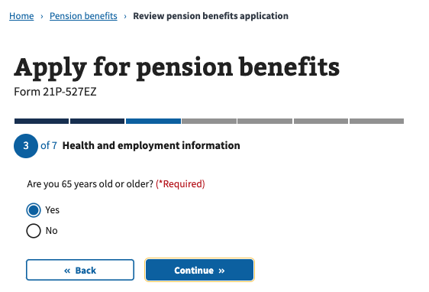

Step 3: Health and Employment Information/Social Security Disability

Next, the Veteran is asked if they currently receive Social Security disability payments.

If they answer “no” to “Are you 65 years old or older,” they see an alert that states they need to provide medical evidence with this application:

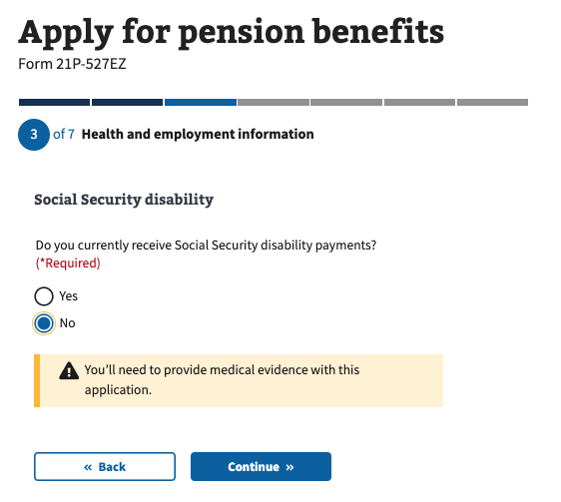

If the Veteran answers “yes” to “Are you 65 years old or older,” they’re asked if they live in a nursing home and if Medicaid covers all or part of their nursing home costs:

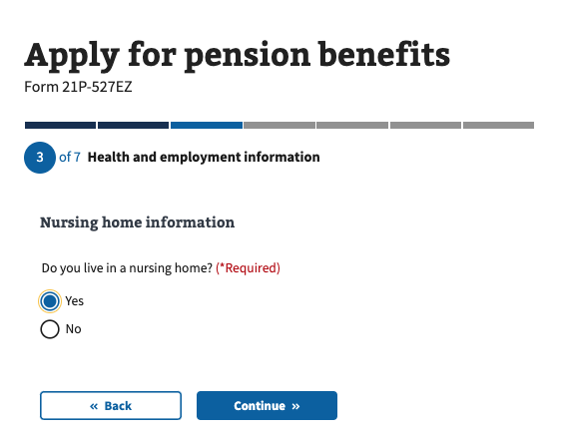

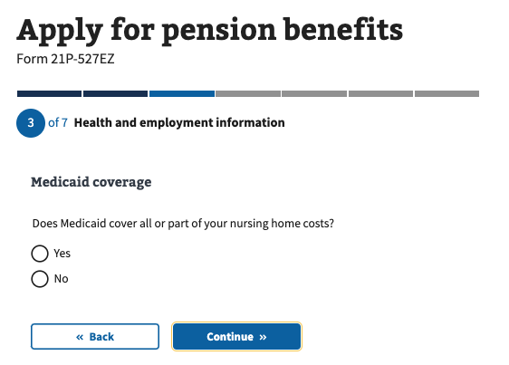

If the Veteran answers “no” to “Do you currently receive Social Security disability payments,” they’re asked additional questions about whether they have a medical condition that prevents them from working.

If they answer “yes,” they see an alert that states they need to provide medical evidence with this application:

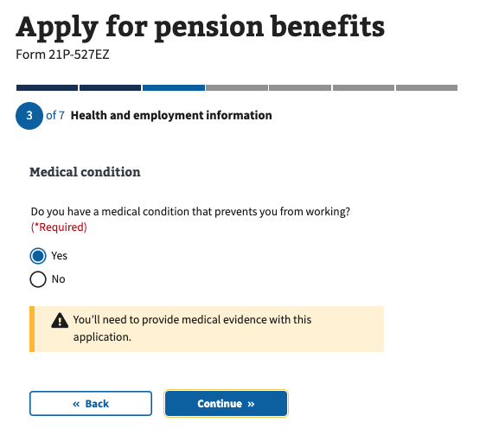

Step 3: Health and Employment Information/Special Monthly Pension

Next, the Veteran is asked if they are claiming special monthly pension.

If they answer “yes,” they see an alert that states they need to fill out VA Form 21-2680.

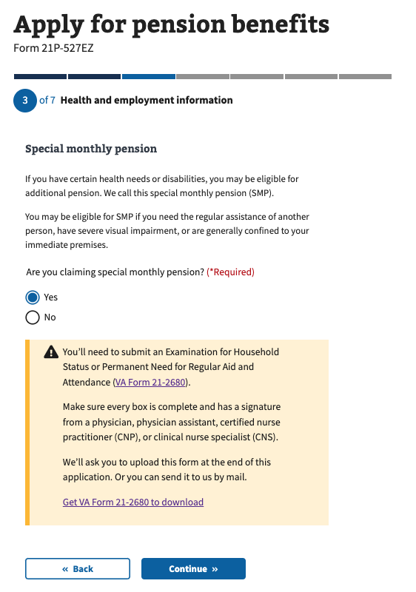

Step 3: Health and Employment Information/Treatment From a VA Medical Center

Next, the Veteran is asked if they have received treatment from a VA medical center. If they answer “yes,” they’re asked where they received treatment.

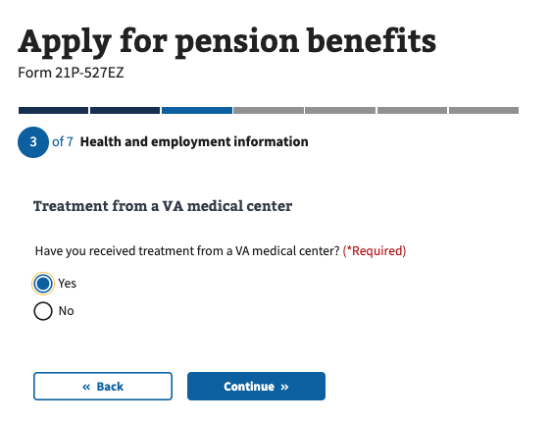

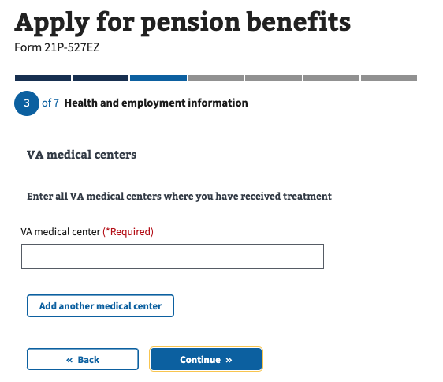

Step 3: Health and Employment History/Treatment From Federal Medical Facilities

Next, the Veteran is asked if they have received treatment from any federal medical facilities, such as military bases or prisons.

If they answer “yes,” they’re asked where they received treatment.

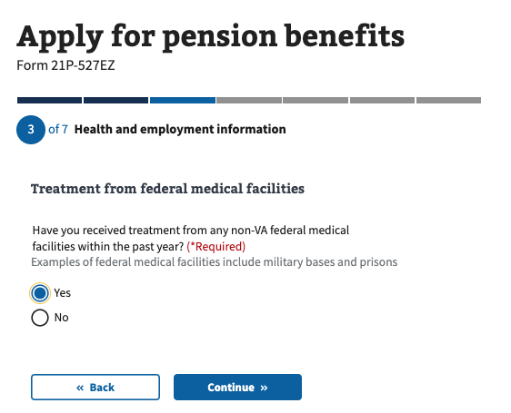

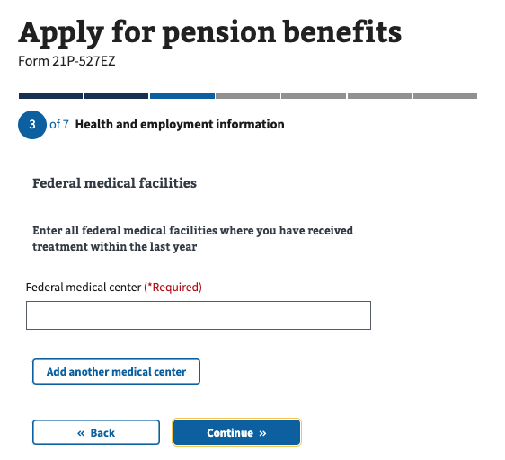

Step 3: Health and Employment History/Current Employment

Next, the Veteran is asked if they are currently employed.

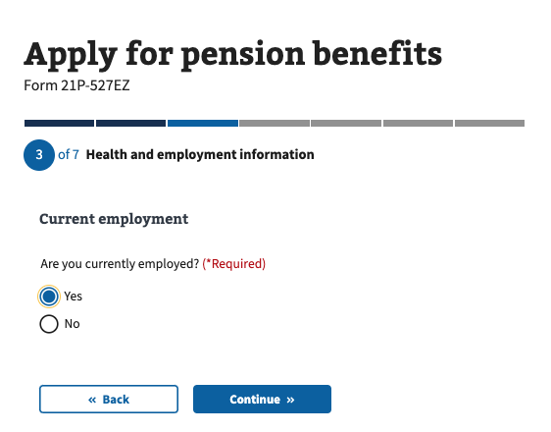

If they answer “yes,” they’re asked to enter what kind of work they do, how many hours per week they work on average, and their job title:

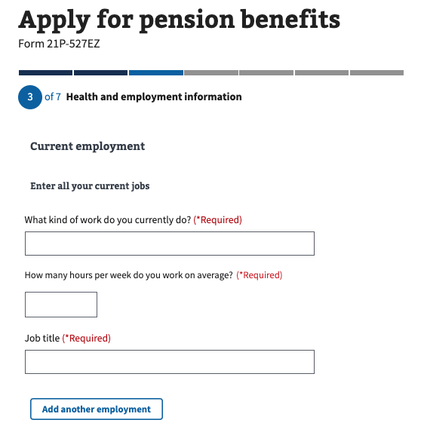

Similarly, if they answer “no” to “Are you currently employed?”, they’re asked to enter a date when they last worked, what kind of work they did, how many hours per week they worked on average, and what their job title was:

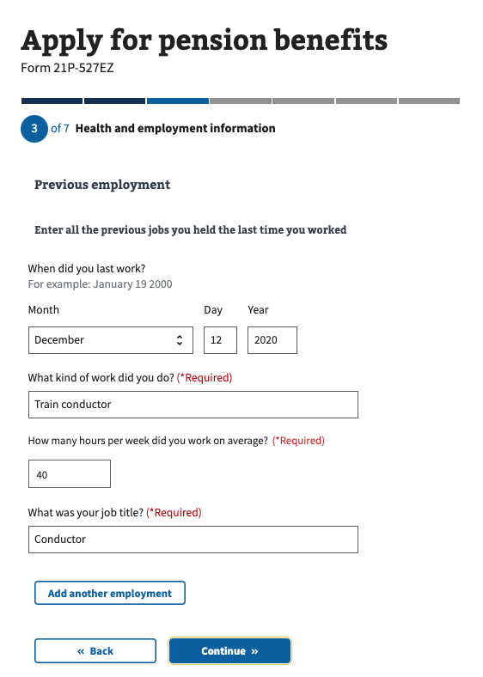

Step 4: Household information/Marital Status

The first question of this step asks the Veteran what their current marital status is:

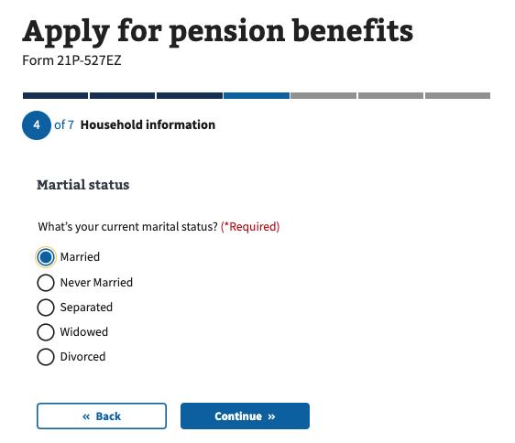

If the Veteran answers “never married,” “widowed,” or “divorced,” they skip to the section that asks about dependent children.

Step 4: Household Information/If Married or Separated

Next, if the Veteran answers “married” or “separated,” they’re asked how many times they have been married:  
  
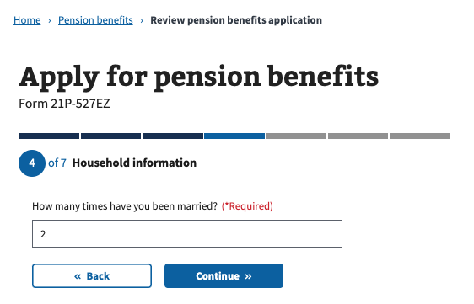

Step 4: Household Information/Previous Marriage

Next, if the Veteran answers “married” or “separated” and they have been married more than once, they’re asked to enter information about their former marriage including their name, dates for start and end of marriage, places of marriage start and end, and how the marriage ended:

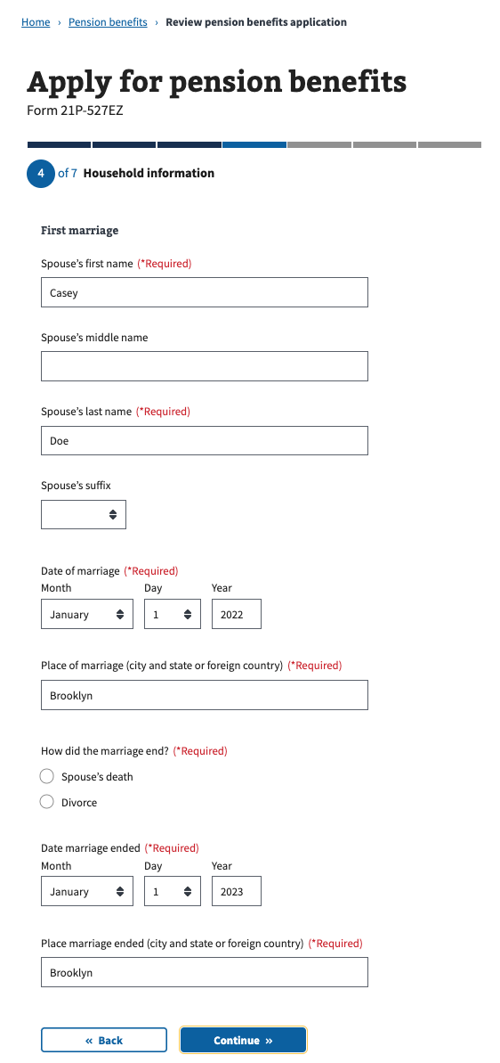

Step 4: Household Information/Current Marriage

Next, if the Veteran answers “married” or “separated,” they’re asked to enter information about their current marriage including their name, date of marriage, place of marriage and type of marriage.

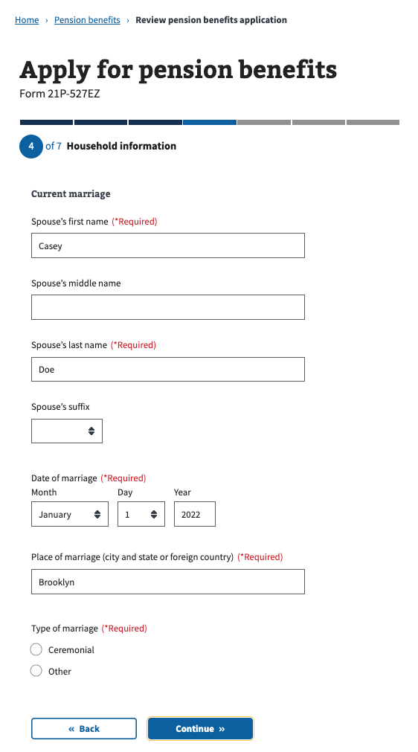

On the next page, they’re also asked about their spouse’s date of birth, Social Security number, if they are a Veteran (if so, add a VA file number), and whether they live with their spouse or not.

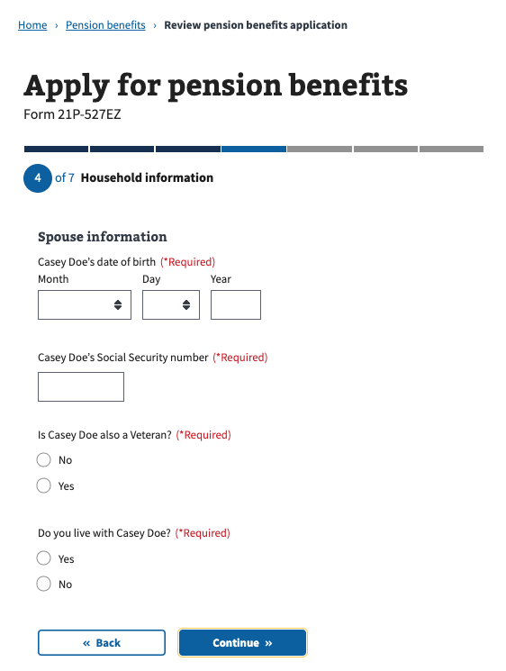

Step 4: Household Information/Current Marriage If They Do Not Live With Spouse

Next, if the Veteran answers that they do not live with their current spouse, the next page asks them what their spouse’s address is.

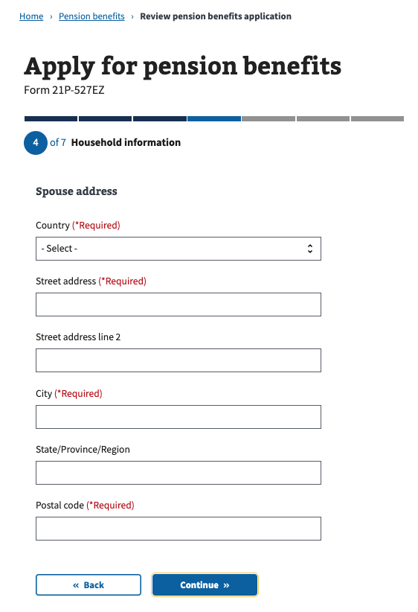

Step 4: Household Information/Current Marriage If They Are Separated

Next, if the Veteran answers “separated” to their current marital status, in addition to their spouse’s address, they’re also asked if about a reason they are separated, and how much money they contribute each month to their spouse’s support:

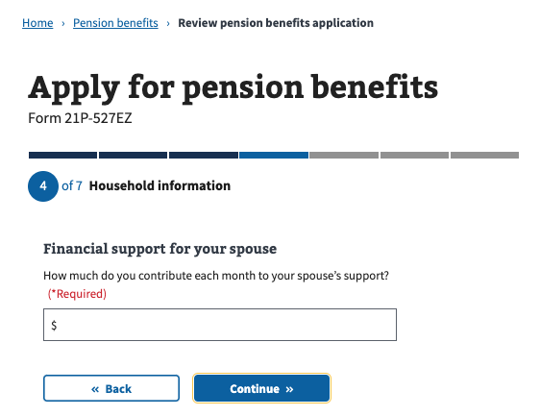

Step 4: Household Information/If Married Or Separated

Next, if the Veteran answers “married” or “separated,” they’re asked if their current spouse has been married before.

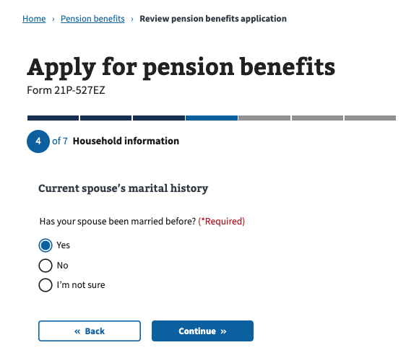

Step 4: Household Information/If Married or Separated/If Current Spouse Was Previously Married

Next, if the Veterans current spouse has been married before, they’re asked about their spouse’s former marriage, including their spouse’s former spouse’s name, how their marriage ended, marriage start and end dates, places where marriage started and ended:

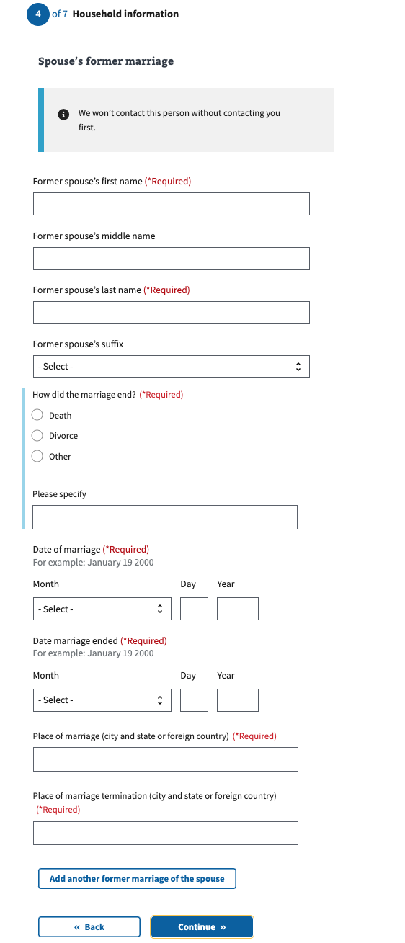

Step 4: Household Information/Dependent Children

Next, the Veteran is asked if they have any dependent children.

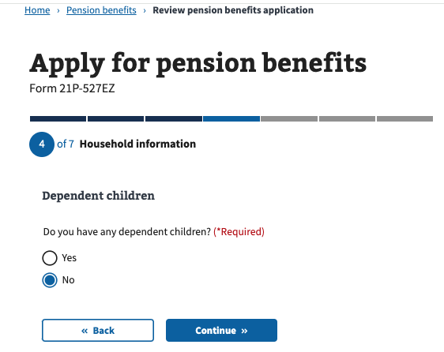

If they answer “yes,” they’re asked about their children’s name, and date of birth. They’re also asked about their place of birth, Social Security number, their relationship with them, if they are seriously disabled, if they are in school (if they are under a set number of years old), and if they’ve ever been married (if so, if they are currently married):

If the Veteran does not have dependent children, they skip to the Financial Information section.

Step 5: Financial Information/Income and Assets

Next, the Veteran is asked if they and/or dependents have over $25,000 in assets.

If they answer “yes,” they see a warning that asks them to fill out VA Form 21P-0969.

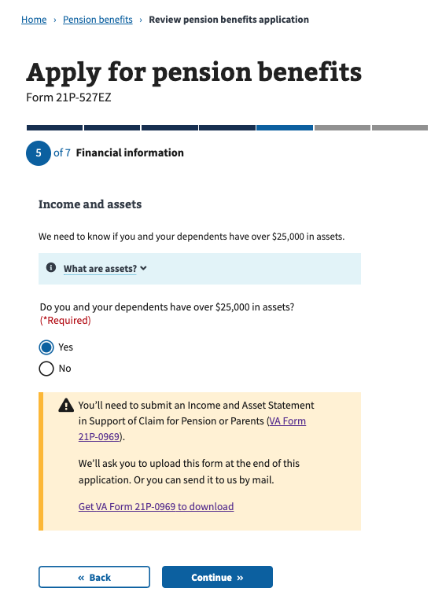

If they answer “no,” they’re asked what the total value of their assets is:

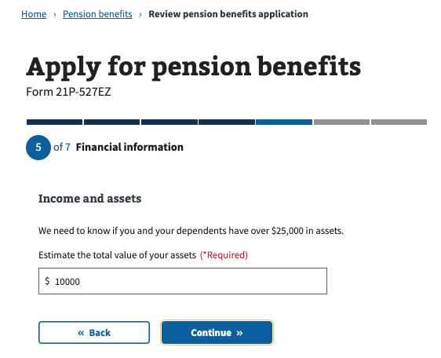

Next, the Veteran is asked if they and/or dependents have transferred any assets in the last 3 calendar days.

If they answer “yes,” they see a warning that asks them to fill out VA Form 21P-0969.

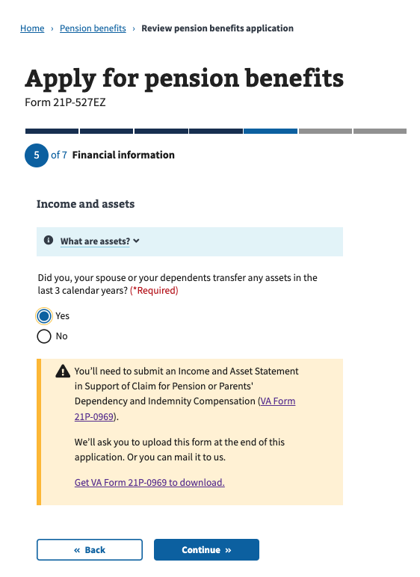

Next, the Veteran is asked if they and/or dependents own their home:

If they answer “no,” they skip to the section that asks about Gross Monthly Income.

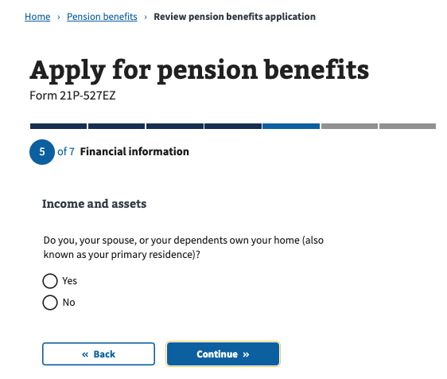

If they answer “yes” to owning their home, they’re asked if their home is located on a lot of land that’s more than 2 acres:

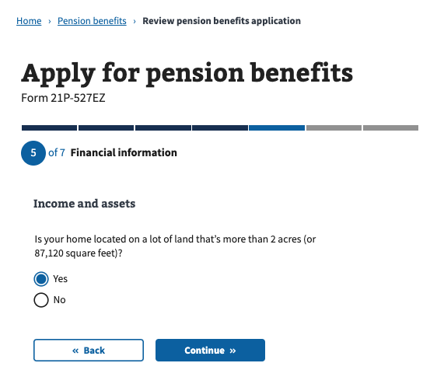

If they answer “no,” they skip to the section that asks about gross monthly income. If they answer “yes” to owning their home, they’re asked what the value of their land that’s more than 2 acres is:

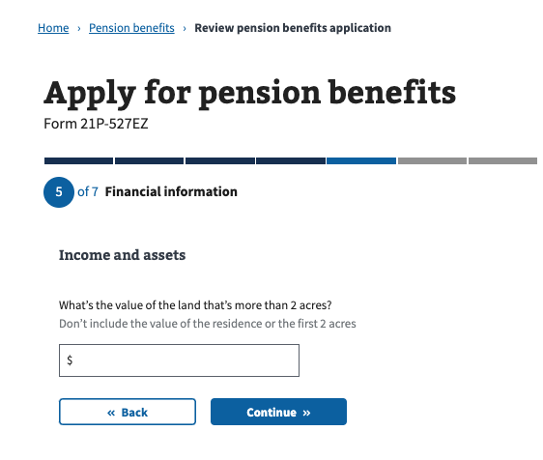

If they answer “yes” to owning a home located on more than 2 acres, they’re asked if their additional land is marketable:

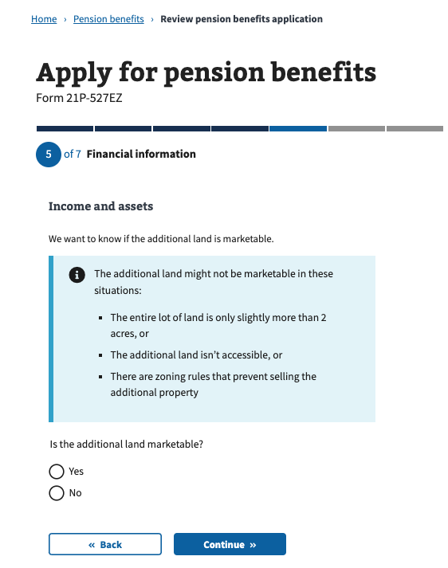

Step 5: Financial Information/Gross Monthly Income

Next, the Veteran is asked if they and/or dependents receive any income.

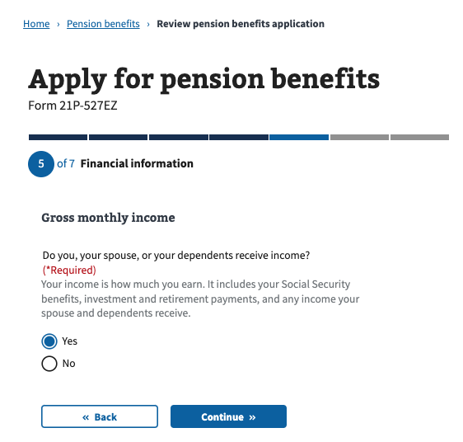

If they answer “no,” they skip to the section that asks about Care Expenses. If they answer “yes,” they’re asked to enter their type of income, who receives the income, who pays the income, and what the monthly amount is:

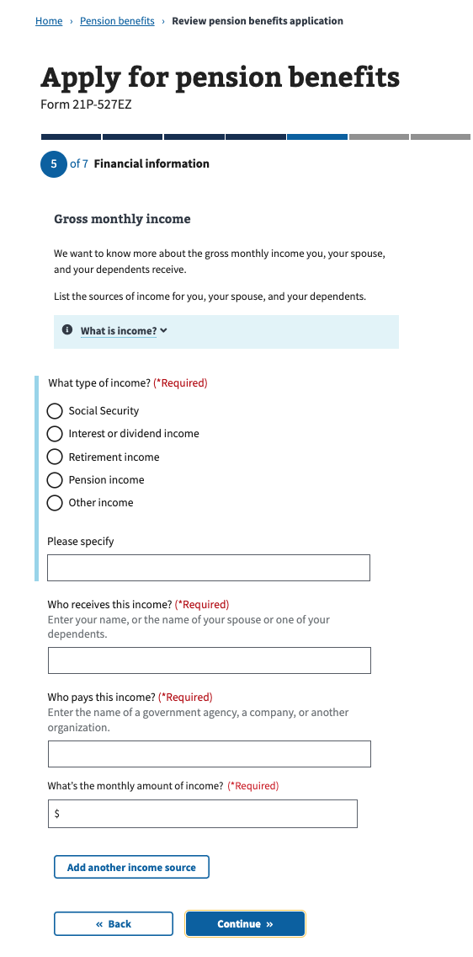

Step 5: Financial Information/Care Expenses

Next, the Veteran is asked if they and/or dependents pay any recurring care expenses that are not reimbursed.

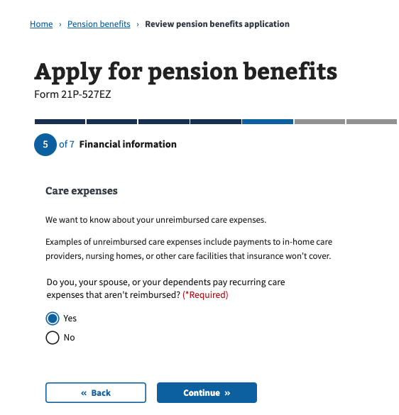

If they answer “no,” they skip to the section that asks about Medical Expenses. If they answer “yes,” they’re asked who receives the care, the name of the care provider, the type of care, what the rate per hour is, how many hours per week their care provider works, the start and end dates of the care, how often their payments occur and the amount of each payment:

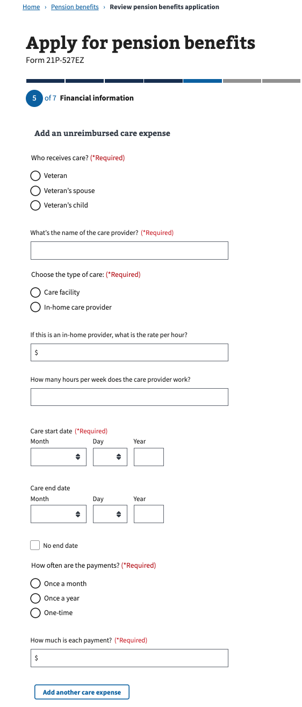

Step 5: Financial Information/Medical Expenses

Next, the Veteran is asked if they and/or dependents pay any medical or other expenses that are not reimbursed:

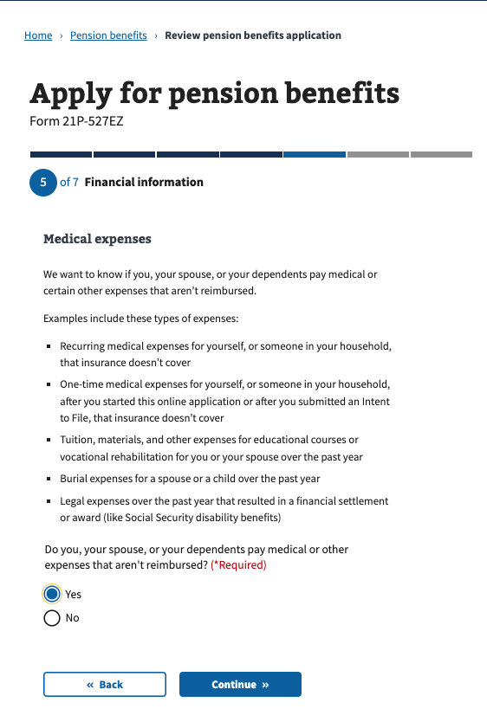

If they answer “no,” they skip to the section to enter their direct deposit information. If they answer “yes,” they’re asked who receives the care, who receives the payment, what the payment is for, date of payment, how often the payments occur, and the amount of each payment:

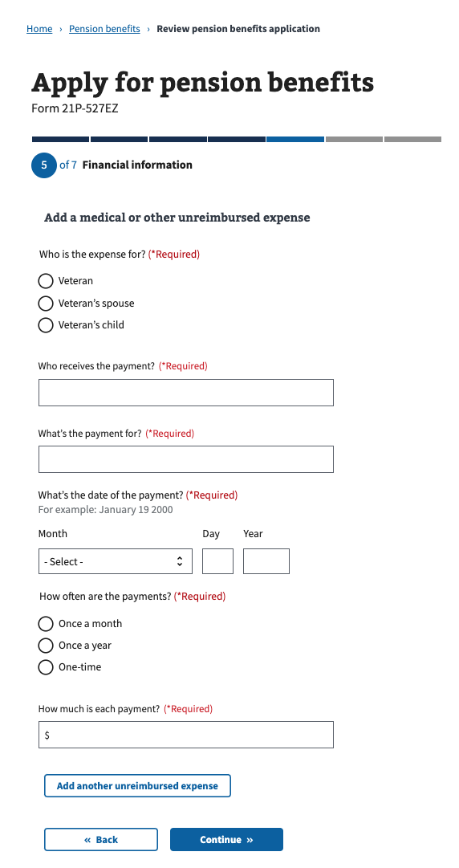

Step 6: Additional Information/Direct Deposit

Next, the Veteran is asked if they want to add their bank account information for direct deposit:

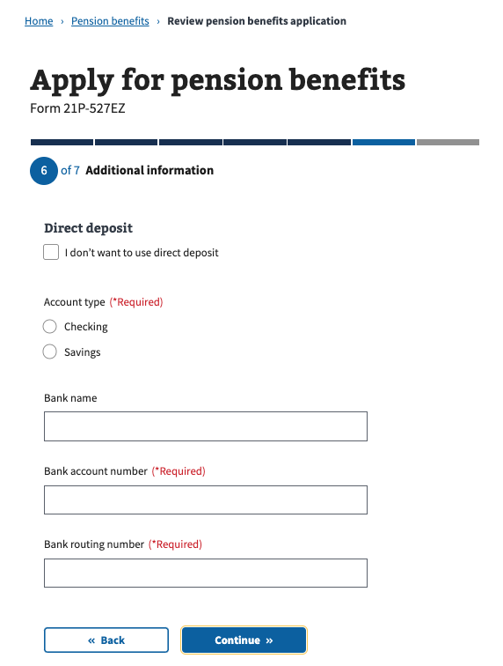

Step 6: Additional Information/Supporting Documents

Next, the Veteran is shown more information about what other types of supporting documentation they need to submit:

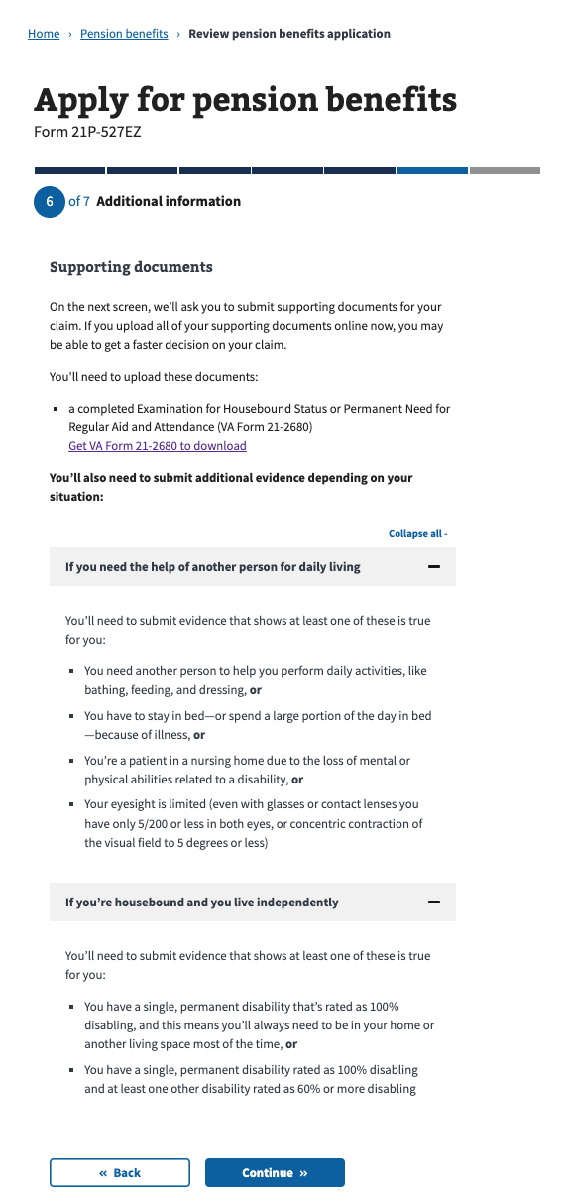

Step 6: Additional Information/Submit Your Supporting Documents

Next, the Veteran can submit supporting documentation. They’re also shown more information about other options to submit, including using the AccessVA tool (QuickSubmit) or mailing their documents:

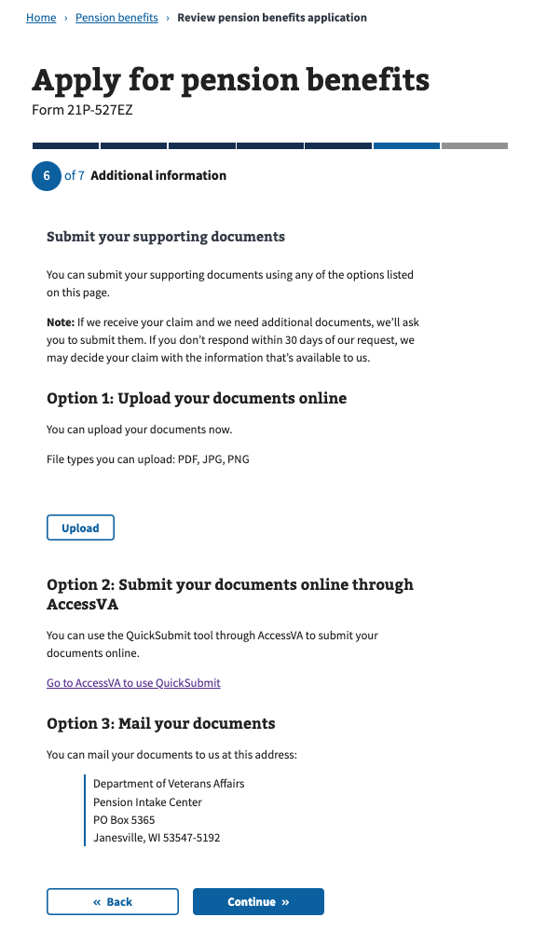

Step 6: Additional Information/Faster Claim Processing (Optional)

Next, the Veteran is asked whether they want to use the “Fully. Developed Claims” program. This is only for applicants who state they have uploaded all their supporting documentation:  
  
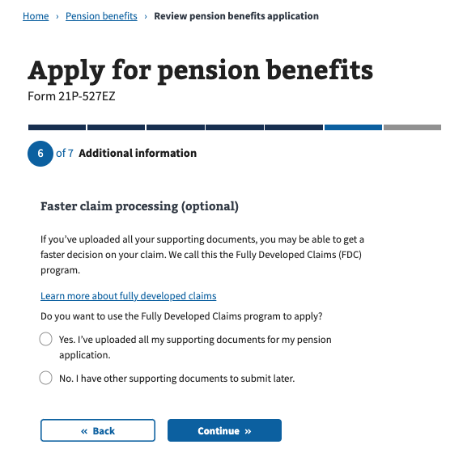

Step 7: Review Application

Next, the application comes to a review section. This is the last step of the form before selecting “Submit Application.” The user sees a summary of all the questions they were asked, as well as any information they entered:

